OOPM Mini Project Report.

-----------------------------------------------------------------------------------

Problem Statement: Flappy Bird

-----------------------------------------------------------------------------------

Objectives:

Implementation of OOP studied in the current Semester in an interactive game. (Flappy Bird )

-----------------------------------------------------------------------------------

Introduction:

Flappy Bird was a mobile game developed by [Vietnames](https://en.wikipedia.org/wiki/Vietnam)e video game artist and programmer Dong Nguye. The game is a side-scroller where the player controls a bird, attempting to fly between columns of green pipes without hitting them.   
 Our project is a minimalized version of the implementation of that game, in which we have implemented the concepts of Object-Oriented Programming and made a simple yet fun UI-based game with the help of awt and swing.

The program detects the input from the user-provided through tapping Spacebar and every time the user taps the Spacebar, it gives a boost to the Y-axis coordinate of the bird. The motive of the game is to pass the maximum number of obstacles (pipes) without colliding.

-----------------------------------------------------------------------------------

Design:

Since the game is targeted towards a younger audience, we decided to design it with the theme of our favorite cartoon - ‘Shinchan’. The gameplay, rules, and controls of the game would stay the same as the classic Flappy Bird, just the theme/visuals would differ from the original.  
-----------------------------------------------------------------------------------

Analysis:

The player controls the bird (head of Shinchan in this case), which moves persistently to the right. The player is tasked with navigating it through pairs of pipes that have equally sized gaps placed at random heights.   
The head automatically descends and only ascends when the player taps the Spacebar. Each successful pass through a pair of pipes, award the player one point. Colliding with a pipe ends the gameplay.

-----------------------------------------------------------------------------------

TEAM:

Yash Sarang.  
Om Gaydhane.  
Muhammad Faayez.

-----------------------------------------------------------------------------------

Code with Results:

*CODE:*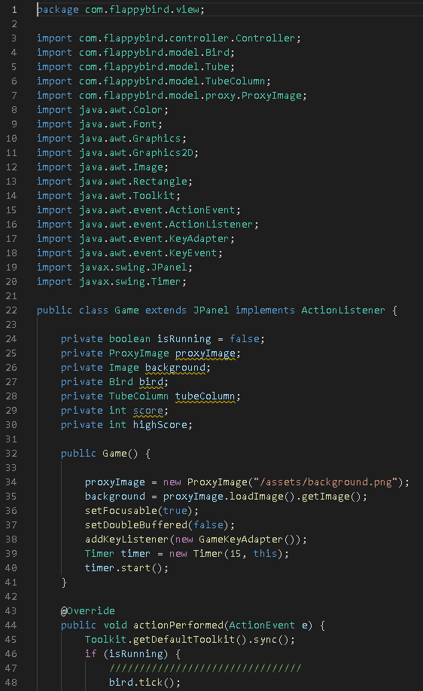

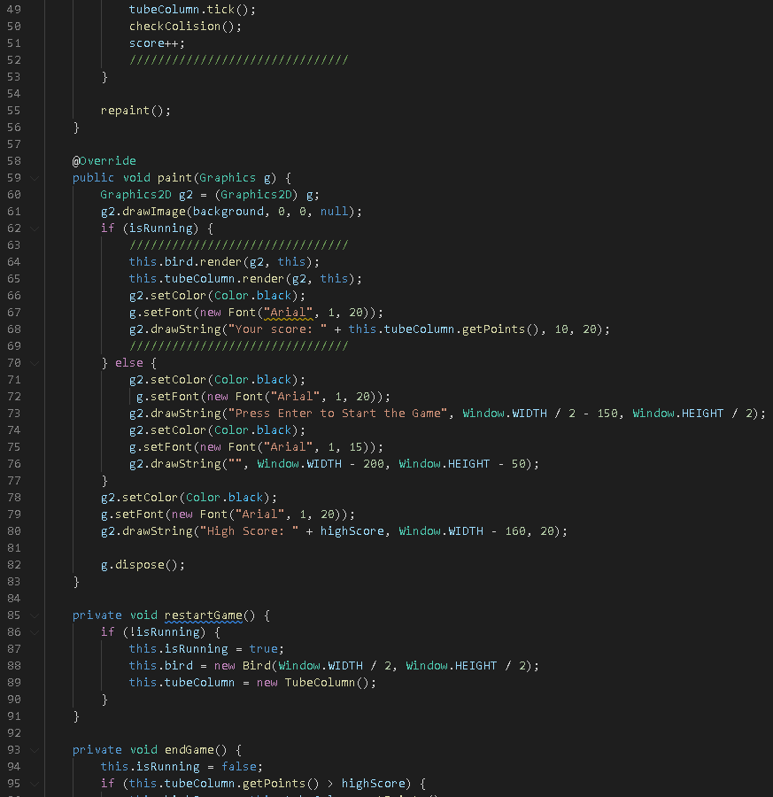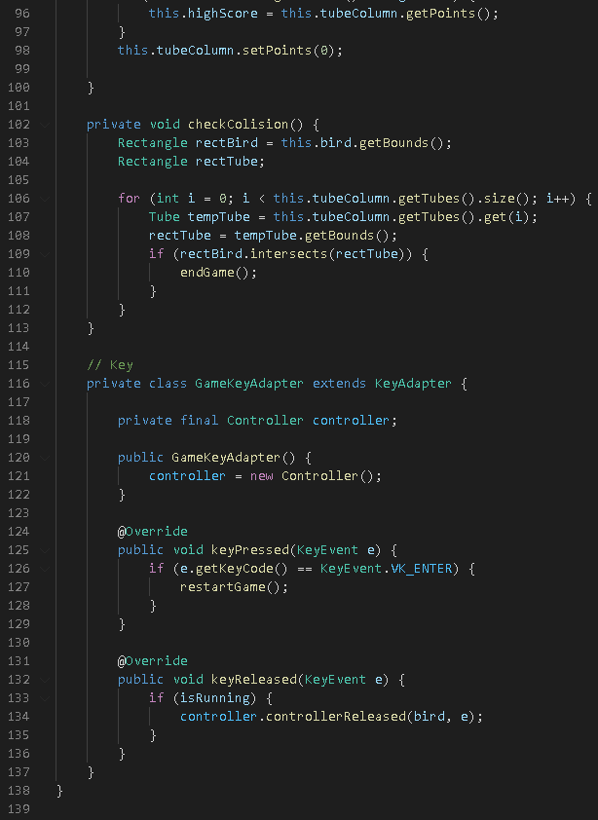

*OUTPUT SCREENS:*

